General questions:
1. Write a brief summary about I2C protocol.
I2C stands for Inter-Integrated Circuit. It is a bus interface connection protocol incorporated into devices for serial communication. It was originally designed by Philips Semiconductor in 1982. Recently, it is a widely used protocol for short-distance communication. It is also known as Two Wired Interface(TWI).
Serial Data (SAD) – Transfer of data takes place through this pin.
Serial Clock (SCL) – It carries the clock signal.
I2C operates in 2 modes –
- Master mode
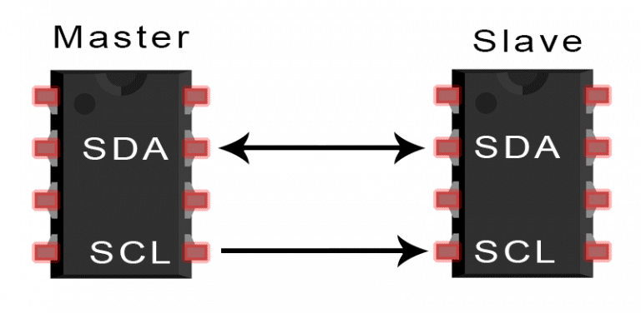
- Slave mode

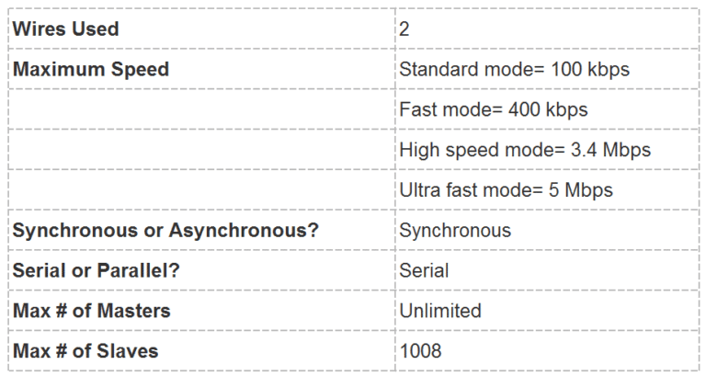
2. Write short text about, pull up resistor, pull down resistor, open drain, active low, active high.
Pull up resistor :
A pull-up resistor connects unused input pins to the dc supply voltage, (Vcc) to keep the given input HIGH.
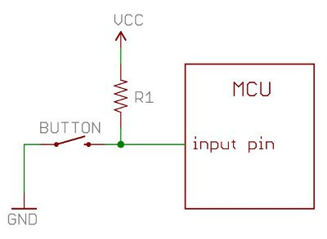

Pull down resistor :
A pull-down resistor connects unused input pins (OR and NOR gates) to ground, (0V) to keep the given input LOW.
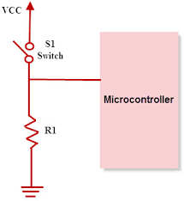

Open drain:
An open-drain or open-collector output pin is driven by a single transistor, which pulls the pin to only one voltage (generally, to ground). When the output device is off, the pin is left floating (open, or hi-z).

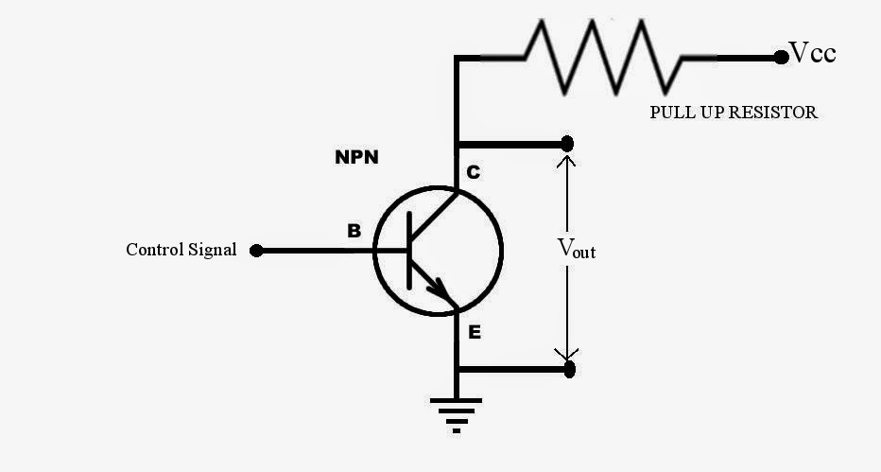

Active low :
If it's an active-low pin, you must "pull" that pin LOW by connecting it to ground.

Active high :
For an active high pin, you connect it to your HIGH voltage (usually 3.3V/5V).
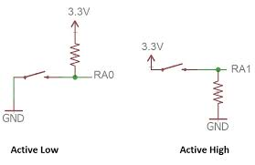

3. Short text about Linux booting process and the role of Kernel.
Linux booting process :
SIX STAGES OF LINUX BOOTING PROCESS:-
1.BIOS(Basic Input/Output System)
2.MBR(Master Boot Record)
3.LILO or GRUB
LILO:-LInux LOader
GRUB:-GRand Unified Bootloader
4.Kernel
5.init
6.Run Levels

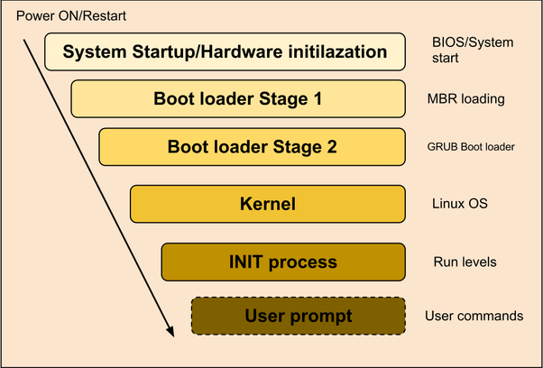

The role of Kernel :
Once GRUB or LILO transfers the control to Kernel,the Kernels does the following tasks
- Intitialises devices and loads initrd module
- mounts root filesystem

4. Text about first impression on Zephyr RTOS.
The Zephyr Project is a scalable real-time operating system (RTOS) supporting multiple hardware architectures, optimized for resource constrained devices, and built with security in mind

